A Comparative Machine Learning Framework for Heart Attack Risk Prediction Using Data Preprocessing, Class Imbalance Handling, and Cross-Validation
Authors:
Dr. Adnan Amin and Shahid Azam

Abstract
This present study is to create a comparative machine learning (ML) framework to predict heart attack by combining systematic data preprocessing, handling of class imbalance, feature selection, hyperparameter optimization, and five-fold cross-validation. Six supervised machine learning models were tested: Logistic Regression, Random Forest, Decision Tree, Gradient Boosting, LightGBM, AdaBoost and Multi-Layer Perceptron (MLP) Neural Network with the help of accuracy, recall, precision, F-1 score, ROC-AUC and confusion matrices. The results showed that Logistic Regression and Random Forest showed the highest accuracy and Decision Tree and MLP showed the highest F1 Scores and recall with regards to detecting the minority classes. The results of the present study highlight that the use of accuracy is not enough if the data set is imbalanced in healthcare. The results of the present study provide the basis for a system and reliable framework for improving heart attack risk prediction, and intelligent clinical support systems for early prevention of cardiovascular diseases.
Keywords: Heart Attack Prediction, Machine Learning, Data Preprocessing, SMOTE, Cross-Validation, Predictive Analytics

1: Introduction
The growing prevalence of hypertension, diabetes mellitus, obesity, sedentary lifestyles, etc., increases the incidence of heart attacks across countries [1]. According to the World Health Organization (WHO), millions of individuals die every year due to cardiovascular complications, while many others experience long-term disabilities that significantly reduce their quality of life. Traditional methods for diagnosing heart attacks largely depend on physician expertise, patient history, electrocardiography, and various clinical examinations [2]. However, relying on traditional analytical techniques limits predictive performance and reduces the ability to identify high-risk patients accurately. In contrast to conventional approaches, machine learning methods can identify nonlinear interactions among multiple predictor variables, simultaneously making them particularly suitable for analyzing healthcare datasets that contain numerous demographic, laboratory, lifestyle, and physiological characteristics [3]. Machine learning algorithms can automatically learn complex correlations for all potential clinical scenarios. Researchers have implemented a wide range of supervised machine learning algorithms, i.e., Logistic regression [4] Decision Tree [5], Random Forests, Support Vector Machines [3], etc., that have demonstrated encouraging predictive capabilities by identifying relationships among cardiovascular risk factors.
The current study proposes a comparative machine learning framework for heart attack prediction that integrates comprehensive data preprocessing, feature preparation, class imbalance handling, hyperparameter optimization, cross-validation, and comparative evaluation of multiple supervised learning algorithms. Data cleaning, missing value treatment, feature encoding, normalization, standardization, and feature selection collectively improve dataset quality and enable algorithms to learn more meaningful relationships among predictor variables [6]. Similarly, in many clinical datasets, the number of healthy individuals considerably exceeds the number of patients diagnosed with heart attacks, where machine learning algorithms trained using such imbalanced datasets often become biased toward the majority class because minimizing overall classification error encourages the model to predict the dominant category more frequently [7] [8] [9].
Therefore, addressing class imbalance is one of the most important considerations in developing clinically reliable machine learning systems. Combining oversampling and under-sampling methods modifies the distribution of observations before model training, which enhances sensitivity, balanced accuracy, and overall model reliability [2]. Thus, the current study’s framework is intended not only to identify the most effective predictive model but also to provide healthcare practitioners and researchers with a reproducible methodology to support early heart attack detection and evidence-based clinical decision-making.

2: Literature Review
One area of artificial intelligence (AI), known as "machine learning," enables computers to identify patterns in existing information and make predictions without being programmed for each situation [1]. The conventional diagnostic methods adopted are based on clinical examination, imaging techniques, electrocardiograms, etc., which are effective but time-consuming and costly, and require specialized healthcare workers [10]. Machine learning is well-suited to the healthcare context because the complex, multi-dimensional nature of changes in disease development over time makes it difficult to model non-linear interactions among multiple clinical variables using traditional statistical methods. Previous works [11] [12] [13] have mainly used traditional classification methods, such as “Logistic Regression”, “Decision Trees”, “Naïve Bayes”, “Support Vector Machine”, and “K-Nearest Neighbors”, which have shown promising predictive results and the potential of machine learning for cardiovascular disease prediction. More recent studies [14] [15] [16] have introduced ensemble learning techniques, such as “Random Forest”, “Gradient Boosting”, “Extreme Gradient Boosting”, “AdaBoost,” and “LightGBM”, which typically outperform individual weak learners by averaging their predictions.
Ensemble learning algorithms frequently demonstrate superior predictive stability because they reduce variance and improve generalization by combining multiple decision trees or weak learners [1]. Despite its computational efficiency, simplicity, and interpretability, Logistic Regression's predictive power drops when high levels of non-linearity occur between clinical features, making it less useful in more complex healthcare datasets [2]. On the other hand, Decision Trees recursively partition the data into smaller sets by using the most informative predictor variables, which leads to the tree structure. The tree structure gives a visual representation of the decision-making process and the variables that contribute most to predicting a heart attack [17]. Random Forest has been one of the most popular ensembles learning algorithms, often outperforming individual decision Trees in terms of accuracy and robustness [18]. The algorithms build numerous decision trees from random subsets of observations and predictor variables, then fuse their forecasts in a majority voting manner, which significantly reduces model variance, decreases the chance of overfitting, and ensures high predictive accuracy in a wide range of health care datasets [19].
Light Gradient Boosting Machine (LightGBM) is an enhanced decision tree growing algorithm that is fast and memory efficient without sacrificing prediction performance, and thus is ideally suited to large-scale healthcare datasets with a large number of predictor variables [20]. Adaptive Boosting (AdaBoost) combines multiple weak classifiers by assigning greater importance to observations that were incorrectly classified during previous learning iterations, which exhibit reduced robustness in the presence of excessive noise or extreme outliers, because misclassified observations receive increasing emphasis during successive learning iterations [7]. An artificial neural network, also called multi-layer perceptron (MLP), consists of a number of interconnected neurons organized into so-called input, hidden, and output layers [9]. Together, these neurons learn complex non-linear relationships among predictor variables by spotting complex interactions between clinical variables that conventional statistical techniques might miss.
Model evaluation and performance evaluation are essential aspects of machine learning as they are deciding factors whether a predictive model can generalize well on new and unseen data. Effective data validation allows researchers to test the robustness and reliability of predictive models as well as their applicability in clinical settings before implementation [12]. The training set is used to teach algorithms how to relate the predictor variables to the disease outcome, and the testing set is used to test the predictive ability of the model on a set of data that has not been used before [1]. In cross validation, the dataset is repeatedly split into several subsets, each of which is used to learn the model at some point and each of which is used to validate the model at another point during the learning process [14].
Cross validation helps to prevent over-fitting and to make the performance measures more confident, due to multiple training and validation cycles. The key measure of predictive ability is the estimation of accuracy, which is a measure that can be easily interpreted, namely that of correctly classified observations. Precision is another commonly reported assessment metric since it measures the proportion of correct positive predictions over all positive predictions of the model [9]. High precision means relatively few healthy people are wrongly classified as heart attack risk, thus minimizing unnecessary clinical investigation and cost of healthcare [20]. Compared to precision, recall refers to the percentage of true heart attack cases that are correctly identified by the prediction model, and the failure to identify high risk patient delay treatment and increase mortality [15]. The F-1 score is a metric that is a hybrid of precision and recall, especially useful for assessing an imbalanced dataset [19]. The advantages of using F-1 score in medical learning research are that it considers both false positive and false negative predictions, which is why it is widely used in medical learning research, particularly in predicting diseases that involve minority class observations [10]. Receiver Operating Characteristic (ROC) curve is a plot that shows the relationship between sensitivity and specificity at various classification levels [18]. On the other hand, Area Under the ROC Curve (ROC-AUC) summarizes the model’s overall ability to distinguish between positive and negative classes [2].
Despite the significant progress in literature, limited attention to comprehensive data preprocessing, feature selection, class imbalance handling, robust model validation, and the use of multiple evaluation metrics has been observed in the literature. The current study develops a systematic machine learning framework that integrates rigorous data preprocessing, feature selection, the synthetic minority oversampling technique, class weighting, hyperparameter optimization, etc. The current study aims to identify a robust predictive model for heart attack risk prediction while providing practical evidence that can support clinicians in early heart attack risk assessment and contribute to the advancement of reliable machine learning applications in cardiovascular healthcare.

3: Research Methodology
The current study used a quantitative research approach to investigate the factors that contribute to heart attacks, utilizing cutting-edge machine learning techniques in order to achieve its goals. The main goal is to use statistical machine learning techniques with SPSS to model the occurrence of heart attacks as a binary dependent variable and to determine the most important contributing factors. The current study's dataset was acquired from Kaggle at (https://www.kaggle.com/datasets/ghnshymsaini/heart-attack-risk-prediction-dataset). Heart attack risk is the dependent variable, and it is coded as a binary variable (1 indicates the presence of heart attack risk, and 0 indicates its absence). Age (continuous variable), sex (binary), total cholesterol, systolic and diastolic blood pressure (continuous variables), smoking habit, and diabetes (binary variables) are examples of independent variables.
Before model development, the dataset was examined to identify missing values, duplicate records, inconsistencies, and potential outliers through using descriptive statistics to understand the characteristics of the data and to ensure that the dataset was suitable for predictive modelling. Following the preprocessing, a feature selection procedure was carried out to identify variables with the greatest relevance to heart attack prediction, and the selected features were subsequently used as input variables for model development [19]. As the majority of observations belonged to the non-heart attack class, the researcher incorporated class imbalance handling techniques to reduce prediction bias using the Synthetic Oversampling Technique (SMOTE) in the training dataset to increase the representation of minority class observations [7]. Class weighting strategies were incorporated into relevant machine learning algorithms to improve their ability to identify heart attack cases. The dataset was split into a training set of 80% and a testing set of 20% so that the training set could be used for model development and optimization and the testing set to evaluate the performance of the model on unseen data. The researcher used five-fold cross validation to decrease the chances of overfitting and to give more reliable estimates of predictive validity. A collection of machine learning algorithms for comparative analysis (logistic regression, random forest, Gradient Boosting, LightGBM, AdaBoost, MLP Neural Network).
Logistic regression is used as a baseline classification model [4]and Random Forest is applied because of its capability of capturing non—linear relationships [16]. Gradient Boosting and LightGBM were selected because they are highly capable in predicting the outcome and have been proven to be effective in handling structured healthcare data [5], while AdaBoost was applied because of its adaptive learning mechanisms, and the MLP Neural Network was applied to explore the effectiveness of deep learning technique in modelling the complex relationship between predictor variables [12]. To enhance the predictive capability of the ML models, the researcher performed a hyperparameter optimization process, and for each algorithm, the hyperparameters were set based on several iterations and validation. To comprehensively evaluate the classification performance of the models developed, various performance metrics, including accuracy, precision, F1 score, Balanced Accuracy and AUC under the ROC curve were calculated. The effectiveness of each model in correctly classifying the heart attack and non-heart attack cases was analyzed by looking at the confusion matrix. The researcher employed commonly used scientific computing methods, Python, as the tool for model development and for assessment.

4: Data Analysis and Key Findings
The researcher kept a balanced class distribution to avoid models being biased towards one class. As both classes were equally represented, the algorithm had enough information to learn patterns related to both heart attack and non-heart attack classes. This type of distribution usually leads to more accurate and fair classification results. The results are presented in Figure 1.
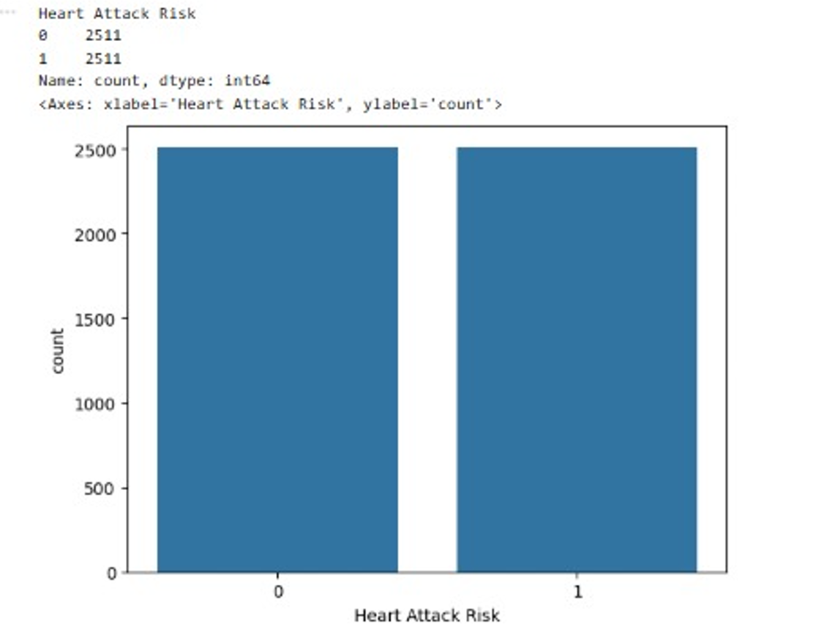
Figure 1: Class Distribution
Figure 2 shows the distribution of the target variable before implementing the balancing technique. The data set was well balanced, with 2511 observations for the non-heart attack class and 2511 for the heart attack class, which represents a perfectly balanced set in which each class has 50% of the data. Balanced distribution provided by SMOTE ensured that machine learning algorithms were provided with an equal number of examples from each class. This is especially of value in the healthcare prediction domain, for which minority cases tend to be the most clinically meaningful cases.
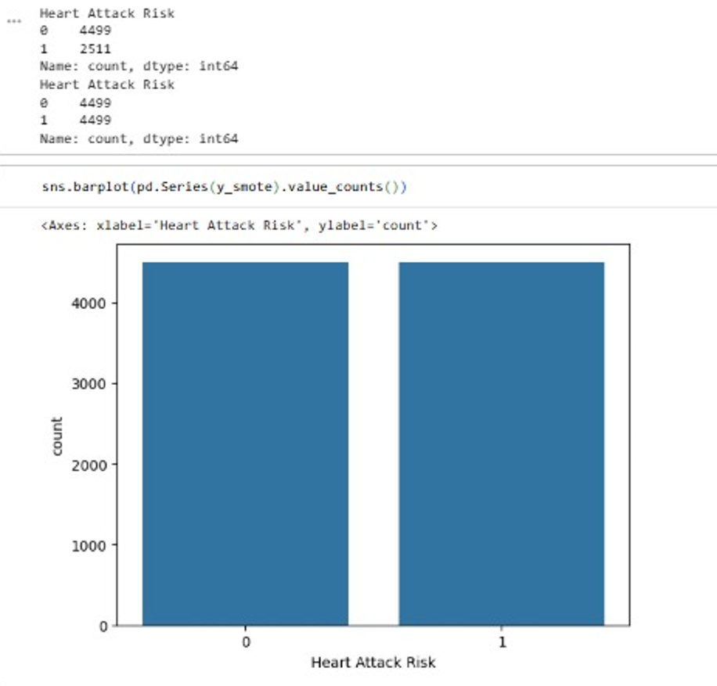
Figure 2: Class Distribution After Applying SMOTE
The distribution of classes following the SMOTE is presented in Figure 2. There were 4499 observations in each class with equal distribution of heart attack and non-heart attack cases, and a balancing effect made the minority class more represented, and a larger dataset was achieved for model training. The logistic regression analysis is used to model the regression, and the following is the process for this regression, i.e., Figure 3.
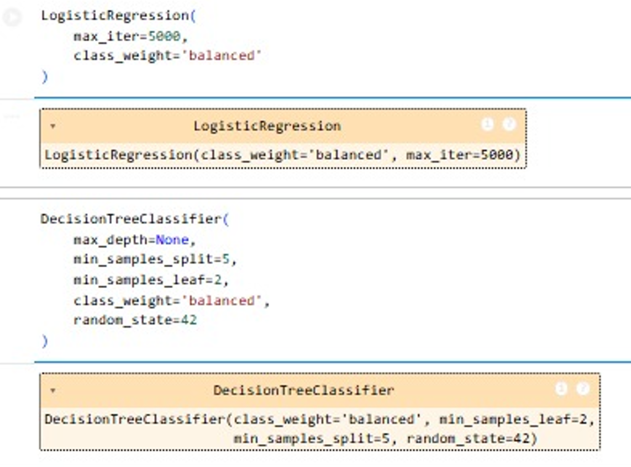
Figure 3: Machine Learning Model Configuration
Figure 3 presents Regression was implemented using balanced class weights and an increased iteration limit of 5,000 to ensure convergence during training. Similarly, the Decision Tree model incorporated balanced class weights and additional parameters to control model complexity and reduce overfitting.
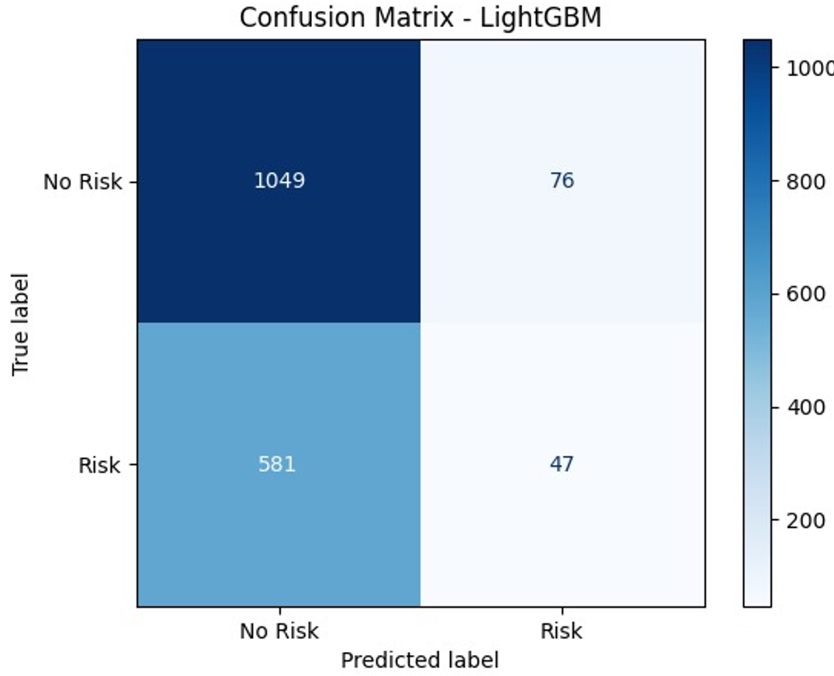
Figure 4: Confusion Matrix of Light GBM
The model accurately identified 47 risk instances and 1,049 non-risk cases from Figure 4. Nevertheless, it misclassified 581 risk instances as non-risk and 76 non-risk cases as risk. This suggests that while the model did a good job identifying those who were not at risk, it had trouble identifying a significant percentage of real risk situations.
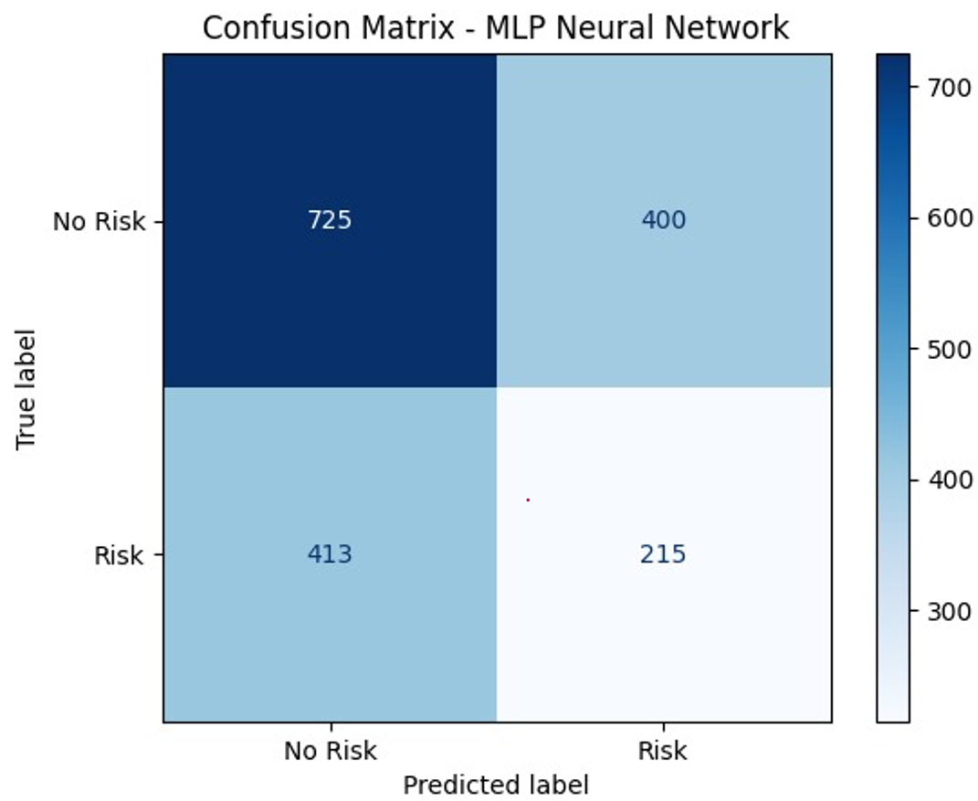
Figure 5: Confusion Matrix: MLP Neural Network
The MLP Neural Network's performance is depicted in the confusion matrix. 215 danger instances and 725 non-risk cases were accurately recognized by the program. In addition, it incorrectly identified 413 risk instances as non-risk and 400 non-risk cases as danger. The MLP Neural Network identified far more heart attack cases than LightGBM, correctly detecting 215 danger cases as opposed to LightGBM's 47. The enhanced identification of real heart attack patients indicates that the neural network showed more sensitivity and more promise for healthcare screening applications, despite an increase in false positives.
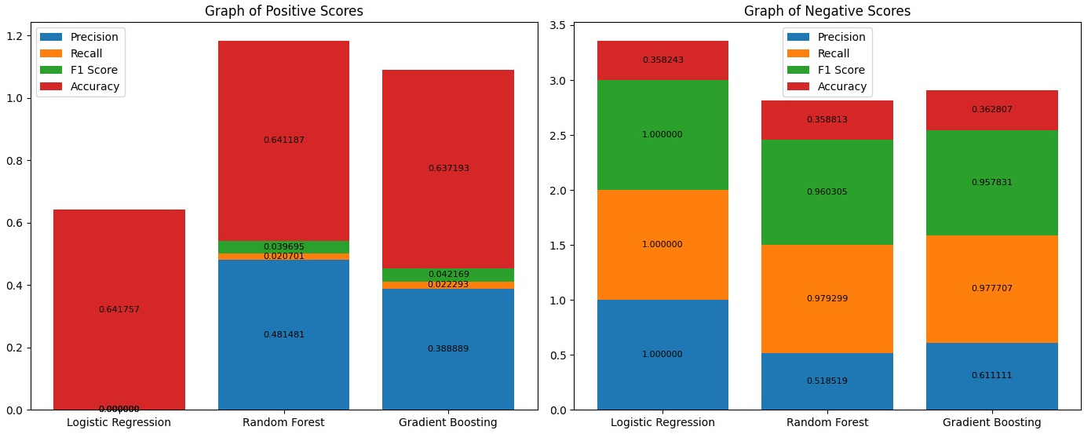
Figure 6: Positive and Negative Performance Score
The precision and recall of the Logistic Regression, Random Forest, and Gradient Boosting models are compared with each other in Figure 6. The precision and recall of the Logistic Regression, Random Forest, and Gradient Boosting models are compared in Figure 6. Random Forest yielded the highest accuracy of around 0.643 and the highest precision of around 0.494 with positive class prediction. Gradient Boosting had a similar performance with an accuracy of around 0.638 and a precision of around 0.389. Logistic regression showed relatively weak scores on most of the performance measures. In the case of the class prediction, Logistic Regression showed a perfect precision and recall of 1.000, which means that it was very good at identifying negative cases. Random Forest and Gradient Boosting, however, had a more even performance distribution between positive and negative classifications, and as such, may be more predictive and stable than Logistic Regression overall.
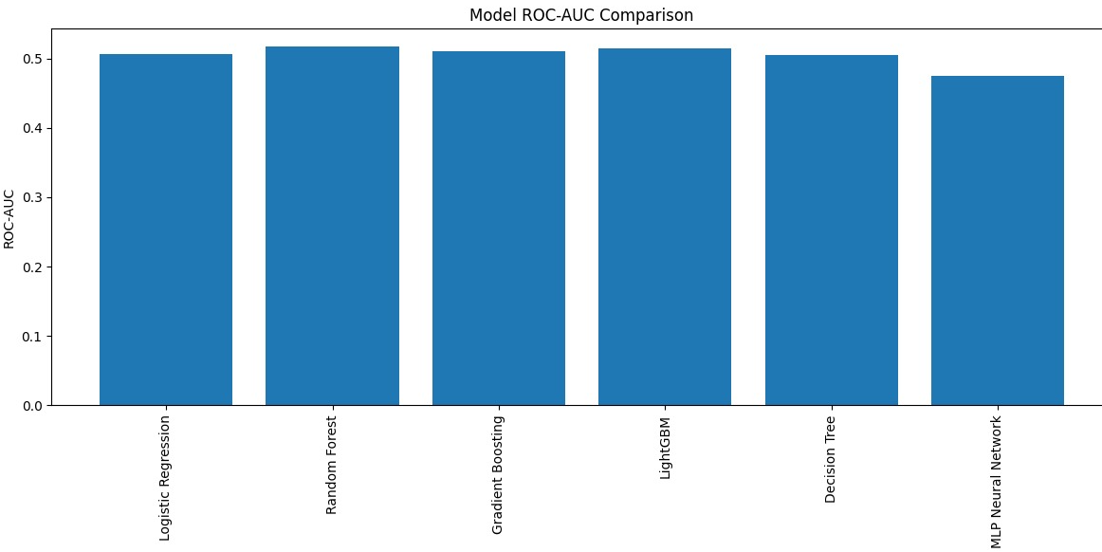
Figure 7: ROC-AUC Comparison
The ROC-AUC value for Random Forest was the highest at ~0.52, followed closely by LightGBM and Gradient Boosting, which had values of ~0.51. The Logistic Regression and Decision Tree models had an ROC-AUC of approximately 0.50, whereas the MLP Neural Network had the lowest ROC-AUC value of around 0.47. The results showed that none of the models had good discriminative ability, and the ROC-AUC values were barely above 0.50. The results indicate none of the models provided good separation between heart attack and non-heart attack cases, since a score of 0.50 is considered random classification.
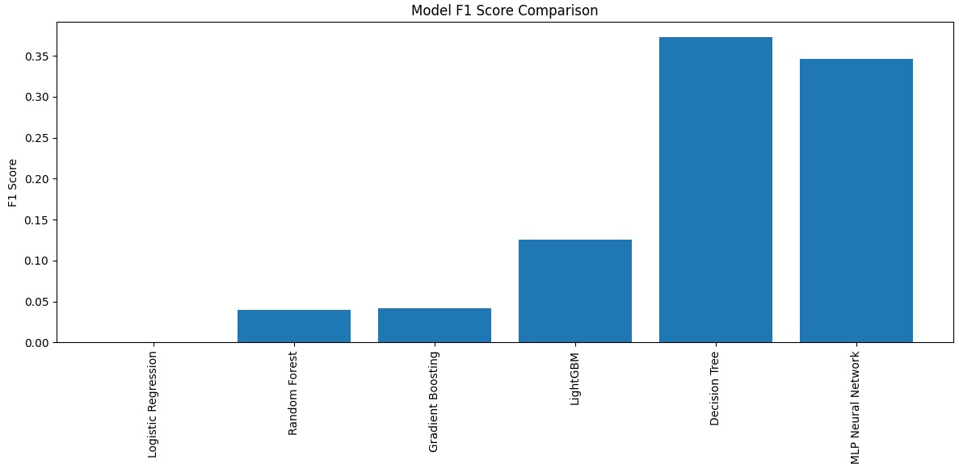
Figure 8: F1-Score Comparison
The comparison of F1-scores of the evaluated models is given in Figure 8. The MLP Neural Network was the second best with an F1 score of about 0.34, closely followed by the Decision Tree with an F1 score of about 0.37. LightGBM had an F1-score of ~0.12, whereas Logistic Regression, Random Forest, and Gradient Boosting had significantly lower scores below 0.05. The results show that Decision Tree and MLP had the best trade-off between precision and recall. Because the F1-score takes into account both values, higher scores indicate better overall classification ability, especially in identifying patients with a heart attack in the dataset.
Logistic Regression and Random Forest had the highest accuracy of around 0.64, closely followed by Gradient Boosting with an accuracy of around 0.63. The accuracy of LightGBM was around 0.62, while Decision Tree and MLP Neural Network had an accuracy of around 0.54. Logistic Regression and Random Forest had the best accuracy scores, but accuracy is not a sufficient measure of performance. In the healthcare environment, this can be more beneficial since less accurate models may increase the sensitivity of identifying patients who have a risk of a heart attack. The accuracy of models is shown in Figure 9.
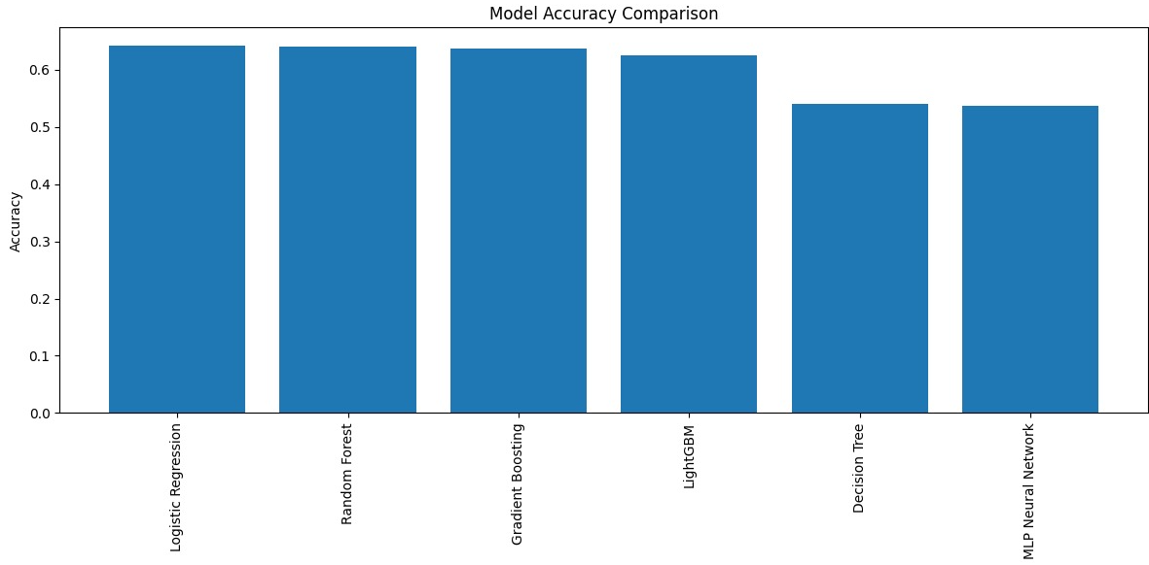
Figure 9: Model Accuracy Comparison
As indicated in Figure 10, the cross-validation values of Accuracy were the best at about 0.60, while Precision was at about 0.35. Recall of about 0.13 and the F1 score of about 0.19.
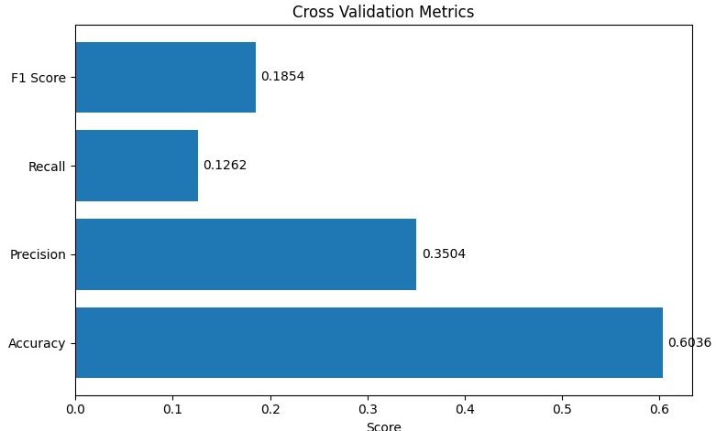
Figure 10: Cross-Validation Metrics
Overall performance of all the tuned machine learning models is summarized in Figure 11. The Logistic Regression and Random Forest models gave the best accuracy scores around 0.64, closely followed by Gradient Boosting and LightGBM with scores above 0.62. The other models, namely Decision Tree and MLP Neural Network, yielded lower accuracy scores around 0.54. For balanced performance, the Decision Tree and MLP Neural Network showed better values of recall and F1-scores than the rest of the models. This suggests that they had less overall accuracy but were better at correctly determining that a patient had a heart attack. For this reason, Decision Tree and MLP might be more valuable for clinical purposes, while Logistic Regression and Random Forest might offer higher overall classification accuracy.
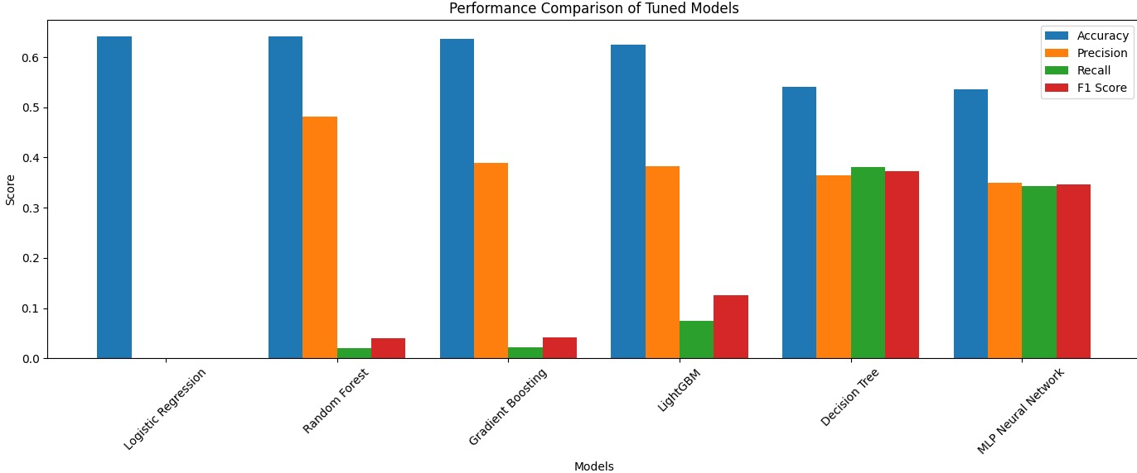
Figure 11: Performance Comparison of Tuned Models
This study demonstrated that the performance of six machine learning algorithms differed in predicting heart attacks. Random Forest and Logistic Regression achieved the best overall accuracy, nearly 64%, followed by Gradient Boosting (63%) and LightGBM (62%), and Decision Tree and Multi-Layer Perceptron (MLP) had an accuracy of approximately 54%. However, Decision Tree and MLP achieved slightly lower overall accuracy but higher F1 scores (0.37 for Decision Tree and 0.34 for MLP), indicating a better trade-off between precision and recall in detecting heart attacks.
The LightGBM confusion matrix showed good classification accuracy in non-heart attack cases with 1049 true negatives and 47 true positives, but poor sensitivity in identifying heart attack risk with 581 false negatives and 76 false positives. Although the MLP model made more such false-positive predictions, the MLP model showed a much higher sensitivity, with 215 heart attacks correctly identified and 725 non-heart attacks correctly identified. Furthermore, the average accuracy of the model was nearly 60%, precision 35%, recall 13%, and F1-score 19% for the cross-validation, which showed a moderate level of generalizability of the model to different folds of cross-validation.

5: Discussion and Conclusion
In the present study, supervised learning machine algorithms have been assessed for predicting heart attack risk through a comprehensive machine learning framework, which involves data preprocessing, handling of class imbalance, feature selection, and cross-validation. The comparative evaluation showed that each algorithm had its own predictive features, which indicated that there are no algorithms that could be said to be universally superior to others in all the evaluation criteria [21]. The results of the present work have shown that overall classification performance is generally better with the use of ensemble learning algorithms: accuracy is not necessarily a good indicator of clinical usefulness, as predictive performance in the medical field should be good at detecting disease-positive cases instead of maximizing the accuracy of the classification [3] [18]. The results of the present study corroborate the findings of previous studies on the applicability of the Random Forest model for structured healthcare data consisting of several clinical and demographic parameters.
Gradient Boosting and LightGBM demonstrated competitive predictive performance, producing overall accuracies only slightly lower than Random Forest [5]. These findings indicate that LightGBM is substantially more effective at recognizing healthy individuals than patients at elevated cardiovascular risk [13]. The findings from the MLP Neural Network provide an interesting contrast to those produced by the ensemble learning algorithms, as it demonstrated a substantially stronger ability to detect heart attack cases. The confusion matrix showed that although the neural network correctly classified 215 cases as positive, the same accuracy was achieved with LightGBM with 47 cases. That is the typical trade-off between sensitivity and specificity that is seen in medical machine learning applications [22].
The comparative evaluation of the machine learning models demonstrated that relying solely on overall accuracy does not provide a.., comprehensive understanding of predictive performance in healthcare applications. The comparison of F1-scores showed that the highest score was obtained by the Decision Tree with around 0.37, followed closely by the MLP with an F1-Score of around 0.34. Logistic Regression, Random Forest, Gradient Boosting, and LightGBM have been found to have relatively higher classification accuracy, though it has been seen to have lower F1-Score. Results from the cross-validation showed an average recall of about 13%, which means that the models succeeded in identifying a limited number of positive heart attack cases in the various folds of cross-validation. A precision of about 35% was obtained during cross-validation, where roughly 33% of the positive predictions were correct. The results indicated that the highest ROC-AUC value was obtained by Random Forest (≈ 52%), which was close to Gradient Boosting and LightGBM values. MLP performed with the lowest ROC-AUC value (≈ 47%). It can be seen from the results that the use of preprocessing, the handling of class imbalance, and the strict validation method collectively increases the robustness and reliability of machine learning models, thus enabling the application of integrated methodological approaches in future studies on healthcare analytics [20] [8].

6: Implications and Study Limitations
From a theoretical point of view, the present study contributes to the current increasing literature of AI and medical informatics, as it highlights how machine learning algorithms cannot be assessed without relying on the analytical framework in which they function [7]. The results of the present research support the theoretical notion that predictive effectiveness is related to algorithm(s) selection and methodology design, not complexity only. The results of the present study show how systematic preprocessing techniques result in better data quality and create a more solid basis for predictive modeling, which emphasizes that quality enhancements of the data sets often yield more significant gains than the use of more sophisticated prediction techniques [18].
The SMOTE technique, when combined with class weighting, is a practical solution in the current study to overcome the biasness in predictions and to improve minority class representation during modelling [15]. Based on this, the comparative machine learning framework mentioned in the present research presents a systematic approach that could be followed by hospitals in the design of a predictive analytics system for cardiovascular disease management [16]. Instead of using machine learning algorithms, healthcare organizations can follow a process of extensive preprocessing, selecting a balanced learning method, using cross-validation and multiple performance measures to choose models that are best suited for their patient population [2].
The data set might not be sufficiently large to be representative of the range of heart attack patients in other hospitals, although it is sufficient to evaluate different machine learning models. Without this, however, other factors, such as physical activity, generic information, psychological stress, etc. may have made it more difficult for the machine learning models to capture the entirety of the risk of heart attack. Moreover, the minority class is still challenging to predict accurately because of the usage of SMOTE and balanced class weighting which was implemented in the present work to prevent the prediction bias. Moving forward, studies will be conducted to overcome these challenges to increase the predictive value, reliability and clinical application of cardiovascular prediction system.

References

[1] | A. Al-Mohannadi, J. Kunhoth, A. A. Najeeb, S. Al-Madeed and K. K. Saddasivuni, “Conventional Clinical Methods for Predicting Heart Disease,” Predicting Heart Failure: Invasive, Non-Invasive, Machine Learning, and Artificial Intelligence Based Methods, pp. 23-46, 2023.
[2] | Z. Wu and C. Guo, “Deep Learning and Electrocardiography: Systematic Review of Current Techniques in Cardiovascular Disease Diagnosis and Management,” BioMedical Engineering Online, vol. 24, no. 1, pp. 23-36, 2025.
[3] | B. Duraisamy, R. Sunku, K. Selvaraj, V. V. R. Pill and M. Sanikala, “Heart Disease Prediction Using Support Vector Machine,” Multidisciplinary Science Journal, vol. 1, no. 2, pp. 2024-2055, 2024.
[4] | S. M. S. Mira, “Binary Logistic Regression Study to Determine the Risk of Heart Attack in 2023,” Matrix Science Medica, vol. 9, no. 4, pp. 96-102, 2025.
[5] | N. Nissa, S. Jamwal and M. Neshat, “A Technical Comparative Heart Disease Prediction Framework using Boosting Ensemble Techniques,” Computation, vol. 12, no. 1, pp. 15-32, 2024.
[6] | F. Gurcan and A. Soylu, “Learning from Imbalanced Data Integration of Advanced Resampling Techniques and Machine Learning Models for Enhanced Cancer Diagnosis and Prognosis,” Cancer, vol. 16, no. 19, pp. 3417-3427, 2024.
[7] | N. Chawla, K. W. Bowyer, L. Hall and W. P. Kegelmeyer, “SMOTE: Synthetic Minority Over-Sampling Technique,” Journal of Artificial Intelligence Research, vol. 16, no. 1, pp. 321-357, 2002.
[8] | N. Gusain, “Cardiovascular Disease Prediction Through Machine Learning: A Comparative Study of Ensemble Techniques,” Revolutionary Advances in Computing and Electronics: An International Journal , pp. 27-40, 2025.
[9] | K. Sirinavas, K. Rani and A. Govrdhan, “Applications of Data Mining Techniques in Healthcare and Prediction of Heart Attacks,” International Journal on Computer Science and Engineering , vol. 2, no. 2, pp. 250-255, 2010.
[10] | A. B. Teshale, H. L. Htun, A. Owen, D. Gasevic, A. Z. Z. Phyo, D. Fancourt, J. Ryan, A. Steptoe and R. Freak-Poli, “The Role of Social Determinants of Health in Cardiovascular Diseases: An Umbrella Review,” Journal of the American Heart Association , vol. 12, no. 10, 2023.
[11] | M. Ozcan and S. Peker, “A Classification and Regression Tree Algorithm for Heart Disease Modeling and Prediction,” Healthcare Analytics, vol. 3, no. 1, 2023.
[12] | R. Yiilmaz and F. H. Yagin, “A Comparative Study for the Prediction of Heart Attack Risk and Associated Factors Using MLP and RBF Neural Networks,” The Journal of Cognitive Systems, vol. 6, no. 2, pp. 51-54, 2021.
[13] | K. H. Zou, J. O'Malleyy and L. Mauri, “Receiver-Opearting Characteristic Analysis for Evaluating Diagnostic Tests and Predictive Models,” Circulation, vol. 115, no. 5, pp. 654-657, 2007.
[14] | E. Dirtas and M. Trigka, “Application of Deep Learning for Heart Attack Prediction with Explainable Artificial Intelligence,” Computers, vol. 13, no. 10, pp. 244-265, 2024.
[15] | A. Amran, S. Suryani, N. A. Fathinah, A. Desiani and R. Indri, “Comparison of Adaptive Boosting and Categorical Boosting in Heart Attack Diagnosis,” Journal of Artificial Intelligence and Software Engineering, vol. 6, no. 1, pp. 44-54, 2026.
[16] | J. Wang, C. Rao, M. Goh and X. Xiao, “Risk Assessment of Coronary Heart Disease Based on Cloud-Random Forest,” Artificial Intelligence Review, vol. 56, no. 1, pp. 203-232, 2023.
[17] | M. Khan, G. Husnain, W. Ahmad, Z. Shaukat, L. Jan, I. U. Haq, S. U. Islam and A. Ishtiaq, “Performance Evaluation of Machine Learning Models to Predict Heart Attack,” Machine Graphics & Vision, vol. 32, no. 1, pp. 99-114, 2023.
[18] | M. N. Kumar, K. V. S. Koushik and K. Deepak, “Prediction of Heart Disease Using Data Mining and Machine Learning Algorithms and Tools,” International Journal of Scientific Research in Computer Science, Engineering, and Information Technology, vol. 3, no. 3, pp. 887-898, 2018.
[19] | M. R. Miah and M. M. Islam, “Data Preprocessing and Feature Engineering Strategies for Large-Scale Predictive Modeling Applications,” Review of Applied Science and Technology, vol. 3, no. 01, pp. 263-302, 2024.
[20] | O. Rainio, J. Teeuho and R. Klen, “Evaluation Metrics and Statistical Tests for Machine Learning,” Scientific Reports, vol. 14, no. 1, pp. 6086-6102, 2024.
[21] | S. Dalal, P. Goel, E. M. Onyema, A. Alharbi, A. Mahmoud, M. A. Algarni and H. Awal, “Application of Machine Learning for Cardiovascular Disease Risk Prediction,” Computational Intelligence and Neuroscience , vol. 1, no. 12, 2023.
[22] | M. H. Al-Adhaileh, M. I. Ahmed-Al-Mashhadani, E. M. Alzahrani and T. H. Aidhyani, “Improving Heart Attack Prediction Accuracy Performance Using Machine Learning and Deep Learning Algorithms,” Iraqi Journal for Computer Science and Mathematics, vol. 6, no. 2, pp. 3-9, 2025.
[23] | B. T. Haque and M. A. Rahman, “Data Preperation and Feature Engineering in High-Dimensional Predictive Modeling,” Journal of Sustainable Development and Policy, pp. 205-244, 2024.
[24] | H. Khan, A. Bilal, M. A. Aslam and H. Mustafa, “Heart Disease Detection: A Comprehansive Analysis of Machine Learning, Ensemble Learning, and Deep Learning Algorithms,” Nano Biomedicine & Engineering, vol. 16, no. 4, 2024.
[25] | G. S. M. Khamis, Z. M. Mohammed, S. M. Alanazi, A. F. Mahmoud, F. a. Abdalla and S. A. Bkheet, “Prediction of Myocardinal Infraction Complications Using Gradient Boosting,” Engineering Technology and Applied Science Research, vol. 14, no. 6, pp. 18550-18556, 2024.

https://www.who.int/publications/b/82976

